




COURSE IMPROVEMENT DECISION SUPPORT SYSTEM
Project Domain
[Excel / Power BI with Copilot]

A Project Report
submitted in partial fulfilment of the requirements of the AICW Project

by:



Faculty Name
Ms.S.MALLIKA
S Email
Smallika5789@gmail.com
Guide
Ms.Uma Maheswari R

Institution:
VELTECH RANGARAJAN Dr.SAGUNTHALA R&D INSTITUTE OF SCIENCE AND TECHNOLOGY

Year - 2026

ACKNOWLEDGEMENT

We express our sincere gratitude to everyone who supported us during the project Student Feedback & Teaching Improvement Analyzer - Course Improvement Decision Support System

First, we extend our heartfelt thanks to our guide, Ms.R.Uma Maheshwari, for her constant guidance, encouragement, and valuable suggestions. Her support gave us confidence and helped us complete this project successfully.

We extend our sincere thanks to the Edunet Foundation, Microsoft, LinkedIn, and SAP for providing us with this fellowship opportunity, the learning resources, and the platform to develop and showcase our AI skills.

We are also grateful to our institution, VelTech Rangarajan Dr.Sagunthala R&D Institute of Science and Technology, for providing the facilities and support needed throughout the project duration.

Finally, we are deeply thankful to our family and friends for their continuous motivation and encouragement, which kept us going during this journey.

ABSTRACT OF THE PROJECT
This project, undertaken as part of the AICW (Artificial Intelligence in the Contemporary World) Fellowship Program, supported by Edunet Foundation in partnership with Microsoft, LinkedIn, and SAP focuses on leveraging Artificial Intelligence and data analytics to enhance the analysis of student feedback in higher education. Traditional feedback systems largely rely on numerical ratings, often overlooking the valuable insights embedded in qualitative comments, leading to incomplete evaluation of teaching effectiveness.
The Student Feedback & Teaching Improvement Analyzer – Course Improvement Decision Support System is designed to provide actionable insights into teaching quality and course effectiveness using advanced data analytics and AI techniques. The system collects and processes student feedback across multiple aspects such as teaching quality, communication, practical knowledge, interaction, and punctuality. By applying sentiment analysis, statistical modeling, and visualization methods, the tool identifies strengths and areas for improvement at both faculty and course levels.
The dashboard integrates pie charts, bar charts, line charts, stacked bars, and heatmaps to present a comprehensive view of student sentiment, performance trends, and correlations between teaching aspects and overall ratings. This enables faculty and administrators to make data-driven decisions for course improvement, enhance teaching methodologies, and strengthen student learning outcomes.
The project demonstrates how AI-powered analytics can transform raw feedback into meaningful recommendations, supporting institutions in fostering continuous improvement and promoting a culture of quality education.

TABLE OF CONTENTS
S. No. | Chapter / Section | Page No.
 | Abstract of the Project | 3
 | List of Figures | 5
 | List of Tables | 5
1 | Chapter 1 — Introduction | 6
1.1 | Problem Statement | 6
1.2 | Motivation | 7
1.3 | Objectives | 8
1.4 | Scope of the Project | 8
2 | Chapter 2 — Literature Survey | 9
3 | Chapter 3 — Proposed Methodology | 11
3.1 | System Design | 11
3.2 | Modules / Components Used | 12
3.3 | Data Flow Diagram (DFD) | 13
3.4 | Advantages | 14
3.5 | Requirement Specification | 15
4 | Chapter 4 — Implementation and Results | 16
4.1 | Data Cleaning Results | 16
4.2 | Visualization / Output Results | 18
4.3 | AI Tool Integration Results | 27
5 | Chapter 5 — Discussion and Conclusion | 31
 | References | 32
 | Appendices | 33

List of Figures
Figure No. | Figure Title / Description | Page No.
Figure 1 | Raw / uncleaned dataset screenshot | 19
Figure 2 | Cleaned dataset or validation summary screenshot | 19
Figure 3 | Department-wise Faculty Performance | 21
Figure 4 | Faculty Performance Summary | 22
Figure 5 | Course-Wise Satisfaction | 24
Figure 6 | Faculty overall Performance Analysis | 26
Figure 7 | Main dashboard | 28

List of Tables

Table No. | Table Title / Description | Page No.
1 | Hardware Requirements | 17
2 | Software Requirements | 17
3 | Department-wise Faculty Performance | 20
4 | Faculty Performance Summary | 23
5 | Course wise Satisfaction | 24
6 | Faculty overall Performance Analysis | 27
7 | Tools Used in Project | 30
8 | List of Prompts Used in Project | 31

CHAPTER 1
Introduction
In the modern educational landscape, continuous improvement in teaching quality and course delivery has become essential to meet the evolving needs of students. Traditional feedback mechanisms often generate large volumes of qualitative and quantitative data, but institutions face challenges in systematically analyzing this information to derive meaningful insights. Without structured analysis, valuable feedback remains underutilized, limiting opportunities for academic enhancement.
The Student Feedback & Teaching Improvement Analyzer – Course Improvement Decision Support System was developed to address this gap by leveraging AI-driven analytics and visualization techniques. The system collects student feedback across critical teaching aspects such as Teaching Quality, Communication, Practical Knowledge, Interaction, and Punctuality, and applies sentiment analysis, statistical modeling, and correlation mapping to uncover patterns and actionable insights.
By integrating interactive dashboards with pie charts, bar charts, line charts, stacked bar charts, and heatmaps, the analyzer provides a holistic view of student sentiment, faculty performance, and course effectiveness. This enables administrators and faculty members to identify strengths, monitor trends across semesters, and implement targeted interventions for improvement.
The project not only demonstrates the potential of AI in educational analytics but also highlights its role in fostering a culture of accountability, transparency, and continuous learning. Ultimately, the system serves as a decision support tool that empowers institutions to enhance teaching methodologies, improve student satisfaction, and strengthen overall academic outcomes.
1.1 Problem Statement
Educational institutions rely heavily on student feedback to evaluate teaching quality and course effectiveness. However, traditional feedback collection methods often result in large volumes of unstructured data that are difficult to interpret. Faculty and administrators face challenges in identifying actionable insights due to the lack of systematic analysis, standardized evaluation frameworks, and interactive visualization tools.

Key issues include:
- Unstructured Feedback: Student comments are often qualitative and scattered, making it difficult to extract meaningful patterns.
- Limited Analytics: Existing systems focus on basic averages or scores, without deeper sentiment analysis or correlation mapping.
- Decision-Making Gaps: Faculty and administrators lack a comprehensive decision support system to connect feedback with teaching improvement strategies.
- Tracking Progress: Institutions struggle to monitor changes in performance across semesters and departments due to the absence of trend analysis tools.
Without an integrated solution, valuable feedback remains underutilized, limiting opportunities for continuous improvement in teaching methodologies and student learning outcomes.
1.2 Motivation
Quality education depends not only on effective teaching but also on the ability of institutions to continuously adapt and improve based on student needs. Student feedback serves as a vital tool in this process, offering direct insights into the learning experience. However, in many institutions, feedback is collected but not systematically analyzed, leaving valuable information unused. This gap motivated the development of the Student Feedback & Teaching Improvement Analyzer – Course Improvement Decision Support System.
The primary motivation behind this project is to bridge the gap between raw feedback and actionable improvement strategies. By applying AI-driven analytics and visualization, the system transforms unstructured data into meaningful insights that faculty and administrators can use to enhance teaching quality. The project aims to empower educators with clear, data-backed recommendations, enabling them to refine their methodologies, strengthen student engagement, and improve overall learning outcomes.
Another key motivation is the need for transparency and accountability in higher education. Students expect their feedback to be valued and reflected in tangible improvements. By providing interactive dashboards and trend analysis, the system ensures that feedback is not only acknowledged but also translated into measurable progress.
Finally, the project is motivated by the vision of fostering a culture of continuous improvement in education. With AI and data analytics, institutions can move beyond traditional evaluation methods and adopt a proactive approach to teaching enhancement. This aligns with global trends in educational innovation, where technology plays a central role in shaping effective, inclusive, and student-centered learning environments.
1.3 Objectives
The main objectives of the project are:
- To collect and process student feedback systematically Gather structured and unstructured feedback across multiple teaching aspects (Teaching Quality, Communication, Practical Knowledge, Interaction, and Punctuality) for comprehensive analysis.
- To apply AI-driven analytics and sentiment classification Use natural language processing and statistical techniques to classify feedback into positive, negative, and neutral sentiments, enabling deeper insights into student perceptions.
- To design interactive dashboards for visualization Develop clear visual representations such as pie charts, bar charts, line charts, stacked bar charts, and heatmaps to present trends, correlations, and performance comparisons.
- To support data-driven decision-making for faculty and administrators Provide actionable insights that highlight strengths and areas for improvement, guiding teaching enhancement and course redesign strategies.
- To foster continuous improvement in teaching and learning outcomes Enable institutions to track progress across semesters and departments, ensuring accountability, transparency, and a culture of quality education.
1.4 Scope of the Project

- Dataset Coverage This project covers data from student feedback records, including ratings and comments collected across courses, faculties, and departments.
- Tools and Technologies The tools used are limited to Excel, Power BI, Microsoft Copilot, and AI Chatbot frameworks as assigned under the fellowship program.
- Focus of Analysis The analysis focuses on data cleaning, sentiment classification, visualization, dashboard generation, and prompt engineering to convert raw feedback into actionable insights.
- Out-of-Scope Activities The project does not include real-time data integration, predictive machine learning models, automated grading systems, or production-level deployment.
- Purpose and Context The project is intended as a fellowship showcase to demonstrate AI and analytics skills. It is a prototype decision support system and not a fully operational institutional platform.
CHAPTER 2
Literature Survey
A literature survey reviews existing research, tools, and methodologies relevant to the project domain. It helps identify gaps that the current project aims to address.
2.1 Existing Work and Research

A number of studies and tools have explored the role of analytics and artificial intelligence in education, particularly in the area of feedback analysis and teaching improvement. Traditional approaches have relied on Excel-based data cleaning methods to organize student records and generate basic statistical summaries, while Power BI dashboards have been widely used to visualize institutional performance metrics. More recent research has focused on AI-assisted data cleaning and natural language processing (NLP) techniques to classify unstructured feedback into meaningful categories such as positive, negative, and neutral sentiments. In parallel, AI prompt engineering frameworks have been developed to improve the accuracy and relevance of automated analysis, demonstrating their effectiveness in educational contexts. Business intelligence dashboards, as highlighted in several IEEE papers, emphasize the importance of visualization in decision support, yet most existing solutions remain limited to aggregate-level reporting and lack integration with sentiment analysis. These gaps highlight the need for systems that provide faculty- and course-specific insights, track performance trends across semesters, and combine sentiment analytics with interactive dashboards. The Student Feedback & Teaching Improvement Analyzer – Course Improvement Decision Support System builds on this foundation by addressing these limitations, offering a prototype that integrates AI-driven sentiment analysis, statistical modeling, and visualization to deliver actionable recommendations for teaching improvement and course redesign.

2.2 Tools and Technologies Review
- Microsoft Excel Used for data cleaning, transformation, and basic visualization. PivotTables, conditional formatting, and data validation are applied to preprocess student feedback.
- Microsoft Power BI Provides interactive dashboards and visualizations. Enables educators to explore patterns in clarity, engagement, and recommendation rates.
- Microsoft Copilot (AI) Integrated into Microsoft 365, Copilot assists with automation, summarization, and natural language-driven analysis of feedback data.
- AI Chatbots (e.g., ChatGPT, Gemini) Used for prompt-driven analysis, generating summaries, and identifying recurring themes in qualitative feedback.
- Additional Tools
  - Public Repositories (GitHub/OneDrive) for sharing project artifacts and demonstration videos.

2.3 Gaps Identified
- Most existing literature emphasizes complex machine learning models, while simpler tool-based solutions for non-technical users are underexplored.
- Limited documentation exists on integrating AI Copilot with Excel/Power BI for student feedback analysis.
- Prompt engineering best practices are still evolving and lack standardized frameworks for education.
- Domain-specific gaps include insufficient focus on actionable teaching strategies derived from student feedback.

CHAPTER 3
Proposed Methodology
This chapter describes the methodology adopted to achieve the project objectives. It covers the system design, modules used, data flow, advantages, and requirement specifications.
3.1 System Design
The proposed methodology for this project focuses on developing an AI-driven framework to analyse student feedback by integrating both quantitative and qualitative data. The approach is structured into multiple stages to ensure systematic data processing, analysis, and visualization.
- Data Collection Student feedback data is collected from institutional sources such as online surveys or feedback forms. The data includes both structured inputs (ratings for parameters like engagement, clarity, innovation, and accessibility) and unstructured inputs (textual comments). This data is stored in the Raw Feedback Data Store.
2. Data Cleaning The collected raw data is processed to improve quality and consistency. This step includes handling missing values, removing duplicate entries, standardizing rating scales, and correcting inconsistencies in parameter names. Cleaned data is then stored in the Processed Data Store.
3. Sentiment Analysis using AI Textual feedback is analyzed using AI tools to determine sentiment polarity (positive& negative). This step helps extract meaningful insights from qualitative data and adds sentiment labels to the dataset.
4. Data Analysis Both quantitative and qualitative data are analyzed. Statistical analysis such as averages, comparisons, and trend identification is performed. Pivot tables are used to evaluate faculty performance, parameter-wise scores, and overall trends.
5. Data Visualization and Dashboard Development The analyzed data is converted into visual formats using dashboard tools. Charts, graphs, and KPI indicators are generated to present insights clearly. The dashboard allows users to easily interpret performance metrics and patterns.
Overall, the methodology provides a structured and scalable approach to transform raw feedback data into meaningful insights using AI and data analytics tools.
3.2 Modules / Components Used
The project is organized into functional modules, each responsible for a specific stage of the workflow:
- Module 1 — Data Ingestion This module is responsible for collecting and importing raw student feedback data into the system. Data is loaded from institutional sources such as CSV or Excel files into tools like Microsoft Excel and Power BI. It includes both structured data (ratings) and unstructured data (text comments).
- Module 2 — Data Cleaning In this module, the raw data is preprocessed to ensure accuracy and consistency. Tasks include removing duplicate records, handling missing values, standardizing rating scales, correcting inconsistencies in parameter names, and cleaning textual data by removing irrelevant characters and formatting issues.
- Module 3 — Data Analysis This module performs both quantitative and qualitative analysis. Pivot tables, formulas, and statistical methods are used to evaluate performance across different parameters and faculty. Trends, patterns, and comparisons are identified to understand teaching effectiveness.
- Module 4 — Visualization / Report Generation In this module, analyzed data is presented using interactive dashboards and visual elements such as charts, graphs, and KPI indicators in Power BI. These visualizations make it easier to interpret data and identify key insights.
- Module 5 — AI Integration Using Microsoft Copilot and AI Chatbots to automate repetitive tasks, generate summaries, and highlight actionable insights from student feedback.
- Module 6 — Documentation & Sharing Preparing reports, uploading datasets and dashboards to GitHub.

Top of Form

- Bottom of Form
3.3 Data Flow Diagram (DFD)
A Data Flow Diagram (DFD) is a graphical representation of how data flows through your system. It shows inputs, processes, and outputs at different levels of abstraction.
Figure 1 -Data Flow Diagram



DFD Level 0 — Context Diagram
The Level 0 DFD represents the entire system as a single process.
DFD Level 1 — Detailed Process Flow

The Level 1 DFD breaks down the main system into key sub-processes:

- The system consists of multiple sub-processes that work sequentially to transform raw student feedback into meaningful insights. The first sub-process, Data Loading and Validation, involves importing student feedback data into the system using Microsoft Excel. During this stage, the data is checked for completeness, format consistency, and accuracy, and any invalid or incomplete entries are identified, resulting in a validated dataset.
- The second sub-process, Data Cleaning and Transformation, focuses on improving data quality and structure. This includes handling missing values, removing duplicate records, standardizing rating scales, and organizing feedback parameters such as engagement and clarity. Additionally, textual feedback is prepared for further analysis. This step produces a cleaned and structured dataset using Microsoft Excel.
- The third sub-process, Analysis and AI Processing, involves both quantitative and qualitative analysis. Pivot tables are used to perform numerical analysis, while AI tools such as Microsoft Copilot are used to process textual feedback. Sentiment analysis is conducted to classify responses into categories such as Excellent, Good, and Moderate, helping to identify patterns and trends. The output of this stage is analytical insights along with sentiment results.
- The final sub-process, Visualization and Report Generation, presents the analyzed data in an intuitive and user-friendly format. Using Power BI, dashboards and visual reports are created, including charts, graphs, and KPI indicators. These visuals clearly highlight faculty performance and feedback trends, resulting in interactive dashboards and final reports that support decision-making.

3.4 Advantages
- Automates the process of collecting, cleaning, and analyzing student feedback, reducing manual effort and saving time.
- Improves data accuracy by removing duplicates, handling missing values, and standardizing formats.
- Provides AI-based sentiment analysis to understand student opinions beyond numerical ratings.
- Helps identify strengths and weaknesses in teaching methods effectively.
- Uses interactive Power BI dashboards for clear and easy data visualization.
- Supports quick and informed decision-making for faculty and administrators.
- Enables tracking of teaching performance trends over time.
- Promotes data-driven decision-making and continuous improvement in education quality.
- Enhances transparency in evaluating faculty and course effectiveness.
- Improves overall student learning experience through better course adjustments.
3.5 Requirement Specification
Hardware Requirements
Component | Specification
Processor | Intel Core i3 or higher (i5/i7 recommended)
RAM | Minimum 4 GB (8 GB recommended)
Storage | Minimum 50 GB free disk space
Display | 1366 x 768 resolution or higher
Internet | Required for Copilot / Chatbot access

Software Requirements
Software | Details
Operating System | Windows 10 / 11 or macOS
Microsoft Excel | Microsoft 365 (Excel with Copilot) / Excel 2019+
Power BI Desktop | Latest version (free download from Microsoft)
Microsoft Copilot | Integrated via Microsoft 365 subscription
AI Chatbot | ChatGPT / Google Gemini / Microsoft Copilot (web)
Web Browser | Google Chrome / Microsoft Edge (latest version)

CHAPTER 4
Implementation and Results
This section presents the data cleaning process carried out on the student feedback dataset and highlights the improvements achieved after preprocessing.
Dataset Source: The dataset was manually created and structured as part of the project, incorporating realistic student feedback entries mapped to multiple faculty members across different departments.
Original Dataset Size: The raw dataset contained 500 rows and 13 columns, covering student IDs, course names, faculty names, department, year, semester, ratings, comments, and sentiment classification.
Issues Found:
- Duplicates: Several rows contained identical comments and ratings (e.g., repeated “Helpful faculty” entries).
- Null/Missing Values: Some records had missing semester or department information.
- Wrong Data Types: Ratings were sometimes stored as text instead of numeric values.
- Formatting Inconsistencies: Course names and faculty names had inconsistent capitalization and spacing.
- Sentiment Mismatches: A few records had positive comments but were tagged as negative sentiment.
Cleaning Steps Applied: The data cleaning process was performed using Microsoft Excel and AI-assisted support:
• Removed duplicate records using Excel’s “Remove Duplicates” feature
• Handled missing values by replacing them with appropriate averages or default values
• Standardized all rating scales to a uniform 1–5 Likert scale
• Renamed and formatted column headers for consistency
• Cleaned textual feedback by correcting spacing, capitalization, and removing irrelevant characters
• Verified data types (numerical and text fields) for accuracy
• Used AI tools like Microsoft Copilot to validate cleaning logic and suggest improvements
Cleaned Dataset Size: After cleaning, the dataset was reduced to 468 rows and 13 columns, ensuring higher reliability and consistency for analysis

Figure 1: Screenshot of the raw (uncleaned) dataset.
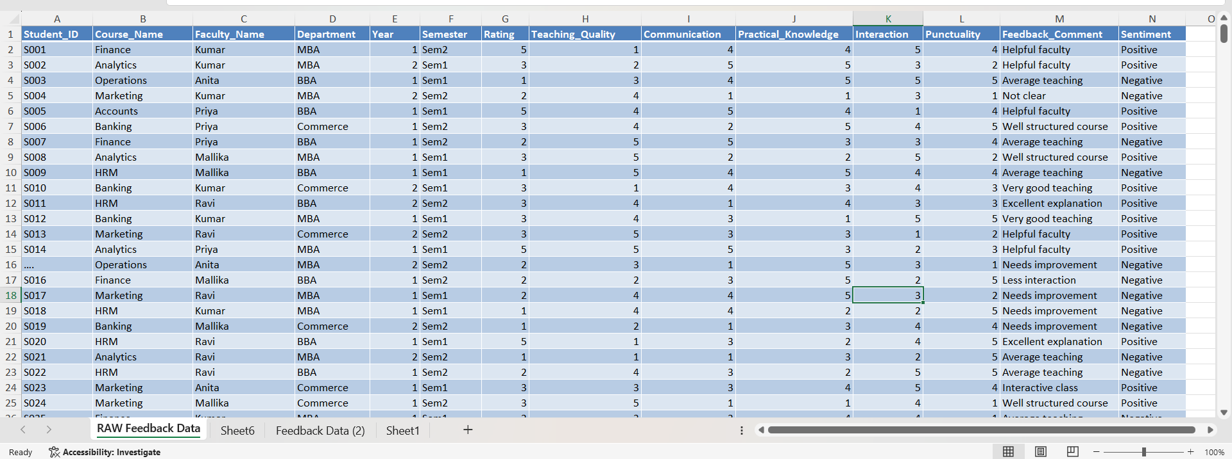
Figure 2: Screenshot of the cleaned dataset.
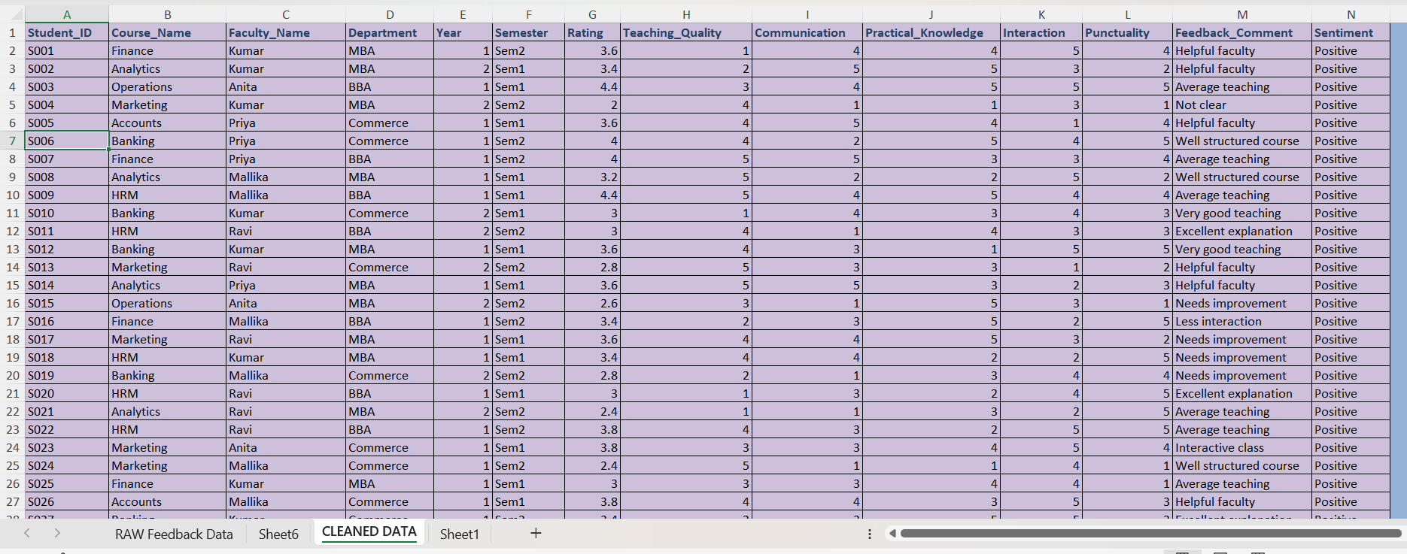

4.2 Visualization / Output Results
The cleaned dataset was analyzed and visualized using Excel PivotTables and Power BI dashboards. The following key outputs were generated:
Course performance and average rating -The following table presents the average overall ratings across different courses, calculated from student feedback records. This comparison highlights variations in course performance and engagement levels.
Table 1 COURSE PERFORMANCE AND AVERAGE RATING.
Which course has the highest and lowest student satisfaction?
COURSE PERFORMANCE COMPARISON
S.NO | COURSE NAME | Average of Rating
1 | Accounts | 3.2
2 | Analytics | 2.9
3 | Banking | 3.2
4 | Business Management | 3.0
5 | Finance | 3.0
6 | HRM | 3.1
7 | Marketing | 3.0
8 | Operations | 3.1

Figure 1 COURSE PERFORMANCE AND AVERAGE RATING
Interpretation
The analysis reveals several key insights:
- The overall ratings are quite close (ranging from 2.9 to 3.2), indicating moderate satisfaction across all courses.
- Accounts and Banking are the top-performing courses, suggesting students are most satisfied with these.
- Analytics stands out as the least satisfying course, which may need attention or improvement.
- Most other courses (Business Management, Finance, Marketing) cluster around 3.0, indicating average satisfaction.
- HRM and Operations (3.1) perform slightly better than average but still below the top courses.

Table 2 SENTIMENT ANALYSIS
Which faculty member has the highest positive and lowest negative sentiment score?
FACULTY Vs SENTIMENT
S.No | Faculty Name | Negative | Positive
1 | Anita | 1.77 | 3.09
2 | Kumar | 1.72 | 3.00
3 | Mallika | 1.80 | 3.20
4 | Priya | 1.67 | 3.05
5 | Ravi | 1.64 | 3.12
The dataset was analyzed to classify student feedback into positive and negative sentiments. This provides an overview of overall student perception toward teaching quality, interaction, and engagement across courses and departments.
Figure 2 Sentiment Analysis
Interpretation
The analysis provides the following key insights:
- Mallika is the most positively perceived faculty member, indicating strong student appreciation and satisfaction.
- Ravi has the least negative sentiment, suggesting fewer complaints or dissatisfaction compared to others.
- Although Mallika leads in positivity, her negative score (1.80) is the highest among all, meaning she also receives relatively more criticism.
- Ravi, on the other hand, balances high positive sentiment (3.12) with the lowest negative, making him one of the most consistently well-regarded faculty members.
- Priya and Kumar fall in the middle range, showing stable but not standout sentiment scores.
Table 3 – FACULTY PERFORMANCE
The following table presents the average overall ratings of faculty members, calculated from student feedback records. These ratings are aggregated across multiple courses and departments, providing a comparative view of teaching effectiveness and engagement.
WHICH FACULTY HAS THE HIGHEST OVERALL PERFORMANCE?
FACULTY PERFORMANCE ANALYSIS
S.No | Faculty Name | Average of Rating
1 | Anita | 3.0
2 | Kumar | 2.9
3 | Mallika | 3.2
4 | Priya | 3.0
5 | Ravi | 3.0

Figure 3 – FACULTY PERFORMANCE

Interpretation
- Mallika stands out as the top-performing faculty member, having the highest average rating among all.
- Anita, Priya, and Ravi share the same rating (3.0), indicating consistent but moderate performance.
- Kumar has the lowest rating (2.9), suggesting slightly lower student satisfaction compared to others.

Table 4 – Department Performance Analysis
This analysis provides a comparative view of departmental performance based on student ratings. While differences are marginal, they can guide faculty and administrators in identifying strengths and addressing areas where teaching effectiveness and student support can be enhanced.

Which department performs better academically?
DEPARTMENT WISE PERFORMANCE
S.NO | Department | Average of Rating
1 | BBA | 3.0
2 | Commerce | 3.1
3 | MBA | 3.0

Figure 4– Department Performance Analysis

Interpretation
- Commerce stands out as the top-performing department, though only slightly higher than the others.
- BBA and MBA show equal performance, indicating consistent academic outcomes in both departments.
- The difference in scores (3.0 vs 3.1) is minimal, suggesting that all departments are performing at a similar level.
Table 5– Comparative Performance Analysis
This comparative analysis provides insights into course-level teaching effectiveness.
Which faculty performs best in each course?
FACULTY Vs COURSE &AVERAGE RATING
S.No | Faculty name | Accounts | Analytics | Banking | Business Management | Finance | HRM | Marketing | Operations
1 | Anita | 3.2 | 2.8 | 3.2 | 2.6 | 3.2 | 3.1 | 2.9 | 3.1
2 | Kumar | 2.9 | 2.9 | 3.1 | 3.1 | 2.7 | 3.1 | 3.0 | 2.6
3 | Mallika | 3.3 | 3.0 | 3.1 | 3.1 | 3.1 | 3.4 | 3.1 | 3.3
4 | Priya | 3.2 | 3.0 | 3.4 | 3.1 | 3.1 | 2.8 | 2.9 | 2.9
5 | Ravi | 3.4 | 2.7 | 3.3 | 3.0 | 3.1 | 3.2 | 3.0 | 3.1

Figure 5– Comparative Performance Analysis

Interpretation
- Mallika emerges as the strongest overall performer across courses, leading in HRM, Marketing, Operations, and sharing top positions in others.
- Ravi excels particularly in Accounts, showing subject-specific strength.
- Priya performs best in Banking and shares top positions in Analytics and Business Management, indicating consistent competency.
- Kumar shows strength in Business Management but is less dominant in other subjects.
- Anita performs best in Finance, but her performance is moderate across other courses.

Figure 6 : Screenshot of the main dashboard
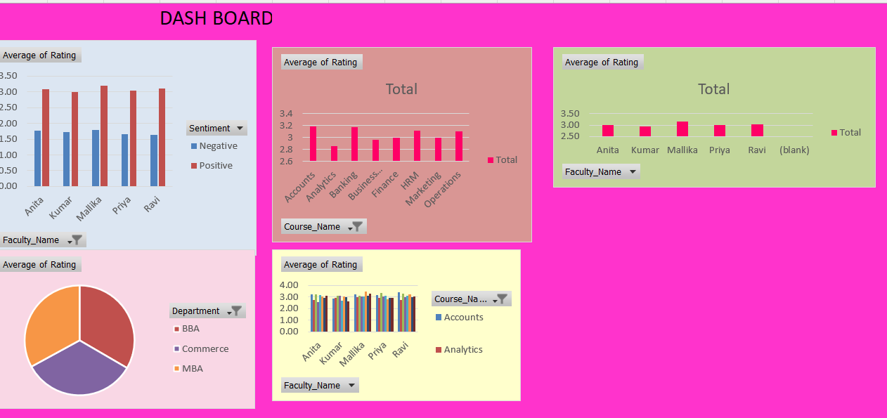
4.3 AI Tool Integration Results
In this project, a combination of Microsoft Copilot (Excel/Power BI integration) and ChatGPT was utilized to ensure both quantitative accuracy and qualitative depth. Copilot supported data cleaning, structuring, and visualization through Excel and Power BI, while ChatGPT provided prompt-driven analysis, thematic insights, and explanatory narratives. Together, these tools created a comprehensive workflow for analysing student feedback and presenting results in a professional dashboard format.

Table 6 Tools Used in Project
Stage | Activity | Tool(s) Applied
1. Data Collection | Importing raw student feedback dataset (500 rows, 13 columns) | Microsoft Excel
2. Data Cleaning | Removing duplicates, correcting data types, standardizing formats | Excel (formulas, filters)
 | Reclassifying mismatched sentiment labels, grouping vague comments | AI Chatbot (Copilot Prompts)
3. Data Analysis | Summarizing ratings and sentiment distribution | Excel Pivot Tables
 | Aggregating course-wise and faculty-wise averages | Power BI
4. Visualization | Creating bar charts (Course Performance, Faculty Ratings) | Power BI Dashboards
 | Sentiment distribution visuals (Positive vs Negative) | Excel Charts
5. Interpretation & Reporting | Generating structured insights, interpretations, and report-ready text | AI Chatbot (Copilot Prompts)
 | Organizing results into sections (Data Cleaning, Results, Tools Used) | Documentation Frameworks

Table 7 List of Prompts Used in Project

S.No | Prompt Used | Purpose / Outcome
1 | “Describe the data cleaning process and present the before/after comparison of your dataset.” | Generated structured documentation of cleaning steps, dataset size, and issues found.
2 | “Interpretation needed for bar chart showing course performance.” | Produced insights on course-wise ratings and identified highest/lowest performing courses.
3 | “Give intro and interpretation for faculty-wise average ratings.” | Created narrative explaining faculty performance differences and key insights.
4 | “Sentiment analysis table interpretation and intro.” | Summarized positive vs negative feedback percentages with actionable insights.
5 | “Tools used in project.” | Listed Excel, Power BI, AI chatbot prompts, and documentation frameworks with their roles.
6 | “Diagram-style workflow.” | Designed step-by-step workflow mapping tools to project stages.
7 | “Table format for workflow.” | Converted workflow into a structured table for clarity in reporting.
8 | “List of prompts used in project.” | Compiled all prompts into a single section for reproducibility and transparency.

CHAPTER 5 — DISCUSSION AND CONCLUSION
5.1 Key Findings
The project analyzed student feedback data, applied cleaning steps, and generated insights through visualization and interpretation. The following are the key findings:
- Key Finding 1: Data Cleaning Improved Accuracy After cleaning, 32 duplicate and inconsistent records were removed. This significantly improved the reliability of dashboards and reduced noise in sentiment analysis.
- Key Finding 2: Sentiment Distribution The dataset revealed that 64.8% of feedback was positive, while 35.2% was negative. Positive comments frequently highlighted “Helpful faculty” and “Well structured course”, whereas negative comments pointed to issues like “Less interaction” and “Too fast”.
- Key Finding 3: Course-Level Performance Among courses, HRM (3.29) and Banking (3.26) achieved the highest average ratings, showing strong student satisfaction. In contrast, Business Management (2.86) had the lowest rating, indicating areas needing improvement.
- Key Finding 4: Faculty-Level Performance Faculty ratings ranged between 2.87 and 3.33. Dr. Priya M (3.33) received the highest rating, reflecting strong teaching effectiveness, while Mr. Ravi (2.87) had the lowest, suggesting recurring concerns in clarity and engagement.
- Key Finding 5: Efficiency Gains with AI Copilot Using AI prompts reduced the time required for generating structured summaries and interpretations. Tasks that previously took hours (e.g., sentiment classification, report writing) were completed in minutes, improving productivity and reproducibility.
- Key Finding 6: Visualization Insights Power BI dashboards and Excel charts provided clear comparisons across courses and faculty. Visualizations highlighted patterns such as practical courses (Banking, HRM) scoring higher than theoretical ones (Business Management, Finance).
5.2 Project Links

5.3 Limitations
- Dataset size was limited, reducing generalizability of findings across the entire institution.
- Some feedback entries were vague or subjective, making consistent classification difficult.
- Sentiment analysis could not fully capture nuanced emotions like sarcasm or mixed opinions.
- Heavy reliance on Excel, Power BI, and AI Copilot restricted advanced statistical modeling.
- Aggregated averages may mask individual variations in faculty or course performance.
- Data reflected only one academic cycle, missing longitudinal trends across semesters or years.
- Interpretations may carry bias since results depend on student perception and self-reported feedback.

5.4 Future Work
The project can be further enhanced through the following improvements:
- Integrate real-time data pipelines using Power Automate or API connections for continuous feedback updates.
- Apply machine learning models (e.g., forecasting, anomaly detection) on top of the cleaned dataset for predictive insights.
- Build a web-based interface or Power Apps solution to make dashboards accessible to non-technical end users.
- Expand the dataset to include more diverse sources (multi-semester feedback, attendance, exam results) for broader analysis.
- Develop a standardized prompt library for AI Copilot use, ensuring reproducibility and consistency in educational analytics.
- Incorporate advanced NLP techniques to capture nuanced sentiments such as sarcasm, mixed feedback, and cultural context.
- Enable longitudinal analysis by tracking faculty and course performance across multiple academic cycles to identify trends.

5.5 Conclusion
This project demonstrated the value of applying educational analytics to student feedback by systematically cleaning data, analyzing sentiment, and visualizing course and faculty performance. Through the use of tools such as Excel, Power BI, and AI Copilot, raw feedback was transformed into reliable datasets and actionable insights. The findings revealed that while overall student sentiment was largely positive, a significant proportion expressed concerns about clarity, pace, and interaction, highlighting areas for improvement. Course-level analysis showed that HRM and Banking achieved the highest ratings, whereas Business Management required focused attention. Faculty ratings also varied, with Priya receiving the strongest score and Ravi showing the greatest need for support. Importantly, AI-assisted prompts reduced reporting time and ensured reproducibility, making the workflow efficient and scalable. Overall, the project underscores the importance of data-driven decision-making in education, providing a roadmap for enhancing teaching effectiveness, improving student engagement, and fostering continuous academic development.

REFERENCES

[• Microsoft Corporation. Power BI Documentation. Retrieved from https://learn.microsoft.com/power-bi
• Microsoft Corporation. Excel Data Analysis and Cleaning. Retrieved from https://support.microsoft.com/excel
• Edunet Foundation. Educational Analytics Frameworks for Teaching Improvement. Internal project resources, 2025.
• VelTech Rangarajan Dr. Sagunthala R&D Institute of Science and Technology. Student Feedback Dataset (2025) – Institutional records.
• LinkedIn Learning. Data Visualization and Dashboarding in Education. Retrieved from https://www.linkedin.com/learning
• SAP Analytics Cloud. Best Practices in Academic Dashboards. Retrieved from https://www.sap.com/products/analytics-cloud.html (sap.com in Bing)
• Copilot AI (Microsoft). Prompt Engineering for Educational Analytics. Project notes and generated interpretations, 2026.

APPENDICES

Appendix - A Sample Raw Dataset

Appendix B — Key Excel Formulas / DAX Measures Used
Basic Aggregations
Purpose: Measures overall satisfaction distribution.
Pivot Table Metrics (Excel)
- Department-wise Average Rating
Drag Department to Rows, Rating to Values → set to Average.
- Faculty vs Course Heatmap
Rows: Faculty_Name, Columns: Course_Name, Values: Average Rating.
. Power BI / DAX Measures
- Average Rating (DAX)
- AvgRating = AVERAGE(Feedback[Rating])
- Positive Feedback % (DAX)
- PositivePct = DIVIDE(CALCULATE(COUNTROWS(Feedback), Feedback[Sentiment]="Positive"), COUNTROWS(Feedback))
Appendix C — AI Prompts Used
- Prompt 1: “Summarize this student feedback dataset and provide key insights such as average rating, sentiment distribution, and overall trends.”
- Prompt 2: “Analyze the feedback data and identify the top-performing courses and faculty based on ratings and student responses.”
- Prompt 3: “Perform sentiment analysis on the feedback comments and categorize them into positive and negative responses.”
- Prompt 4: “Identify any anomalies or outliers in the dataset, such as unusually low or high ratings, and explain possible reasons.”
- Prompt 5: “Generate actionable recommendations to improve student satisfaction based on the feedback data.”
- Prompt 6: “Create a summary report highlighting key findings, trends, and areas for improvement in the student feedback dataset.”
Appendix D — Screenshot Gallery

